As Madonna flies to Malawi to adopt Mercy, her family tell of fears they will never see her again
By Barbara Jones
Last updated at 8:33 AM on 29th March 2009
- Comments (0)
- Add to My Stories

The family of Mercy James, the four-year-old Malawian girl who pop star Madonna wants to adopt, revealed yesterday that they did not want to let her go.
Her uncles, who live in a remote rural area and who are her closest relatives, said they had no idea who Madonna was.
The singer has an appointment with a judge in Malawi tomorrow in the hope that the adoption papers will be signed.
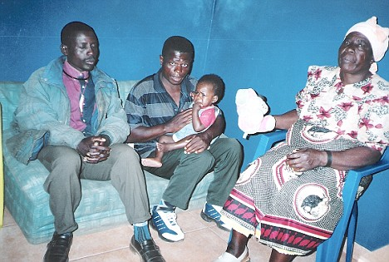
Loving family: Mercy in a snap taken at home with uncles Peter and John and grandma Lucy
But the uncles claimed they would agree only if Mercy would be returned to them once she had completed her education and had a career.
They have been persuaded over a period of two years - ever since Madonna first fell in love with the girl at the Kondanani children’s village near the city of Blantyre - that giving Mercy up for adoption will be in her best interests.

More...
- Madonna¿s former nanny tells of her strain on Facebook
- Children's charity urges Madonna to think again over Malawi adoption plans
But the child’s family, who are among the poorest of the poor in the tiny African country, yesterday said they had been given no clear idea of what the future would hold for Mercy, whose mother died aged 18, five days after giving birth to her and whose father cannot be traced.
Mercy’s uncles, Peter Baneti and John Ngalande, live in mud-brick shacks that have grass thatch roofs.
There is no electricity and their water is collected from a standpipe.
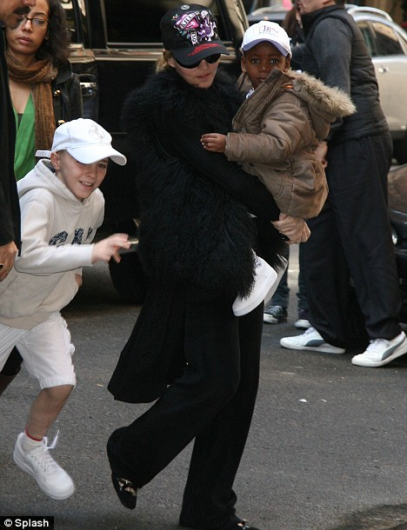
Madonna attends Kabbalah iin New York yesterday with her adopted son David, who is also from Malawi, and her son Rocco
They cannot read or write but will attend the court hearing in Lilongwe, Malawi’s capital, which is a five-hour trip away from their home.
It is their first visit to a city.
Yesterday Peter, a subsistence fisherman, said: ‘We never wanted to let Mercy go. She is part of our extended family and our culture.
‘My mother, my brother and I all said no three times to the orphanage, which was pressing us on Madonna’s behalf.
'Now we have been persuaded that Mercy can have a better, healthier life somewhere else in the world with this rich white woman.
'We never heard of Madonna before. We don’t have a radio or TV because we live without electricity.
'We just heard today that she is a singer.
‘I feel that we need more advice but everything is going so fast. They have taken Mercy from the orphanage and she is already in Lilongwe waiting for this new mother to arrive.
‘We were told there is an important meeting where we must sign papers on Monday, and now we hear it is a court hearing in front of a judge. We have no experience of this sort of thing. We are not sure if we should be saying goodbye to Mercy like this.
‘We cannot afford a lawyer to represent us but my brother and I are going to insist there is an agreement that our niece will come back to us one day. We really need that.’
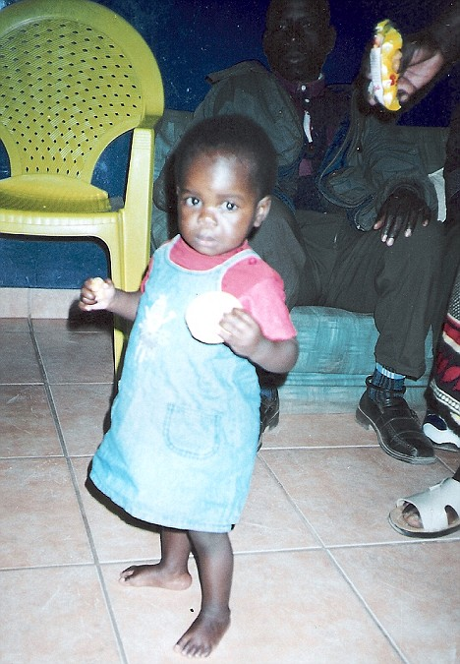
Mercy at home with her family two years ago
He said the director of the orphanage had told them that Mercy would have a good education and come back to Malawi to support her family once she was a doctor
or lawyer.
Peter said: ‘That is a very nice idea but we don’t know if it is true that we can ever see her again. We could never afford to go to America or England. We would have to believe the promises of this white woman.’
Mercy would be the second child Madonna, 50, has adopted from Malawi after David Banda became part of her family in 2006.
Yesterday, his father Yohane Banda complained that he has not seen his son since the day he signed the adoption papers, despite an agreement that he would be able to stay in touch.
He said: ‘I said goodbye to David as Madonna took him away in her arms. I comforted myself then that I would be seeing him regularly and getting news of him.
'But even though Madonna visited Malawi with him last year she did not contact me or bring my son to me. I was very shocked by that.
‘We had a verbal agreement and she promised me that David would stay close to his roots and to me, his nearest relative. She broke that promise and I have heard nothing for two years.
‘Now, suddenly, I have been contacted to say she is coming over again and would like me to meet her and David.’
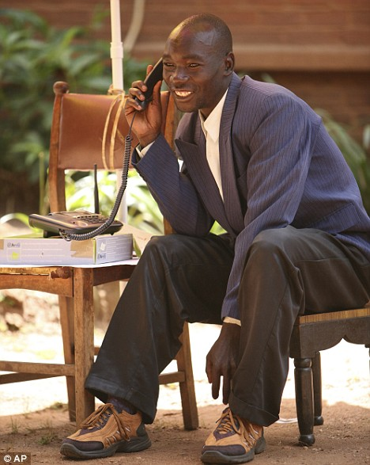
Yohane Banda says he had hoped to stay in touch with his son David, who was adopted by Madonna
On Friday Mr Banda arrived at the luxury Kumbali Lodge hotel in Lilongwe, where Madonna was due to arrive with David today.
If the adoption cannot be completed tomorrow, Madonna hopes that a temporary custody order will allow her to take Mercy home to New York with her to join David, three, and her biological children Lourdes, 12, and Rocco, eight.
Recently divorced from film director Guy Ritchie, Madonna last week also split from Brazilian boyfriend Jesus Luz who was 22 years her junior.
Yesterday Mercy was playing in the lush gardens surrounding Kumbali Lodge where Madonna has had all 13 rooms booked for several weeks.
Mercy and a nanny from the orphanage are sharing a bedroom with a balcony overlooking the nearby forest and hills.
The little girl has made friends with the Malawian gardeners and waiters who call her Chifundo, which means Mercy.
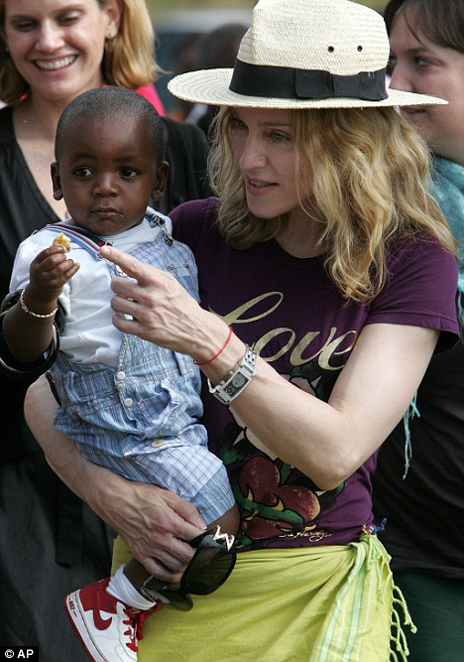
Madonna and David in Malawi soon after his adoption two years ago
One hotel worker said: ‘We have all fallen in love with her. She is a gorgeous child with big round eyes and braided hair. We are sad to hear she will be leaving our country and living with foreigners. It doesn’t seem right.’
Staying close to Mercy at all times is Philippe van den Bossche, executive director of Madonna’s charity Raising Malawi, which aims to provide education, food and shelter for 4,000 children.
The charity’s work is based on Kabbalah, the mystic Judaism sect of which Madonna is a prominent member. She is bringing up her adopted son David in the sect and is expected to introduce Mercy to it.
There is increasing disquiet over her attempt at another fast-track African adoption.
Save the Children has urged her to reconsider.
Spokesman Dominic Nutt said: ‘It is vital, we say, that children should be cared for in their own environment by their own community, ideally by their own family.
'The thing to do is to support the community, the local agencies and the charities who can look after the child.’
Malawian pressure group Eye of the Child has appealed to the Government to make Mercy’s best interests their priority in considering Madonna’s application.
But director Maxwell Matewere said: ‘I think it is too late. This has all been achieved with the utmost secrecy and we heard only two days ago through the media that the adoption is imminent. We are helpless to do anything now that the paperwork
is complete.
‘This is a really sad development. Our adoption laws require foreigners to reside in this country for at least a year before they can be considered as adoptive parents.
‘Somehow Madonna has side-stepped this once, and seems to be about to do it again.’
Mercy’s grandmother Lucy, who is in her 70s and too frail to attend court said: ‘I can see how life could be different for her living in a rich family but I have to face the possibility of never seeing her again.’

- TV&Showbiz>
- A-Z Star Search>
- Madonna

